LAB TASK 9
TASK 1 :
CODE :
#include <stdio.h>
float trScore(int severity, int age, int vitals) {
return (severity * 0.5) + (age * 0.3) + (vitals * 0.2);
}
int main() {
int s, a, v;
printf("Enter severity, age, vitals: ");
scanf("%d %d %d", &s, &a, &v);
float score = trScore(s, a, v);
if (score > 7.0)
printf("Immediate attention required\n");
else if (score >= 4.0)
printf("Moderate priority\n");
else
printf("Can wait\n");

return 0;
}
EXECUTION :
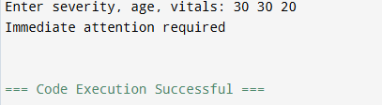

TASK 2 :
CODE :
#include <stdio.h>
float applyDiscount(float price, int tier) {
if (tier == 1) return price * 0.95;
else if (tier == 2) return price * 0.90;
else if (tier == 3) return price * 0.80;
else if (tier == 4) return price * 0.70;
return price;
}
void printInvoice(float original, float discounted) {
float delivery = (discounted < 2000) ? 150 : 0;
float total = discounted + delivery;
printf("\nOriginal: %.2f", original);
printf("\nDiscount: %.2f", original - discounted);
printf("\nDelivery: %.2f", delivery);
printf("\nTotal: %.2f\n", total);
}
int main() {
float price;
int tier;
printf("Enter price and tier: ");
scanf("%f %d", &price, &tier);
float discounted = applyDiscount(price, tier);
printInvoice(price, discounted);
return 0;
}

EXECUTION :
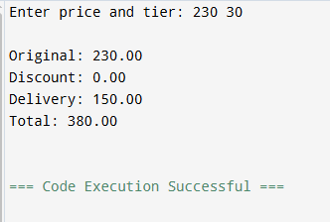

TASK 3 :
CODE :
#include <stdio.h>

int totalRuns(int arr[], int n) {
int sum = 0;
for (int i = 0; i < n; i++){
sum += arr[i];
}
return sum;
}

int highestScore(int arr[], int n) {
int max = arr[0];
for (int i = 1; i < n; i++)
if (arr[i] > max) {
max = arr[i];

}
return max;
}

int aboveAverage(int arr[], int n, float avg) {
int count = 0;
for (int i = 0; i < n; i++)
if (arr[i] > avg){
count++;}
return count;
}

int main() {
int arr[10];
printf("Enter 10 scores:\n");
for (int i = 0; i < 10; i++)
scanf("%d", &arr[i]);
int total = totalRuns(arr, 10);
float avg = (float)total / 10;
printf("Total: %d\n", total);
printf("Average: %.2f\n", avg);
printf("Highest: %d\n", highestScore(arr, 10));
printf("Above Avg Matches: %d\n", aboveAverage(arr, 10, avg));

return 0;
}
EXECUTION :
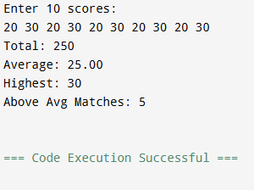

TASK 4 :
CODE :
#include <stdio.h>
int PIN(int stored, int entered) {
return stored == entered;
}
int main() {
int storedPIN = 4729, entered;
for (int i = 1; i <= 3; i++) {
printf("Enter PIN: ");
scanf("%d", &entered);

if (PIN(storedPIN, entered)) {
printf("Access granted\n");
return 0;
} else {
printf("Wrong PIN. Attempts left: %d\n", 3 - i);
}
}
printf("Card blocked\n");
return 0;
}
EXECUTION :
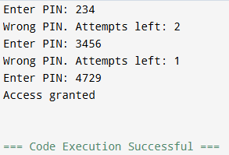
TASK 5 :
CODE :
#include <stdio.h>
float toMJ(float kwh) { return kwh * 3.6; }
float toBTU(float kwh) { return kwh * 3412.14; }
float toCalories(float kwh) { return kwh * 859845; }
int main() {
float kwh;
printf("Enter kWh: ");
scanf("%f", &kwh);
printf("MJ: %.2f\n", toMJ(kwh));
printf("BTU: %.2f\n", toBTU(kwh));
printf("Calories: %.2f\n", toCalories(kwh));
return 0;
}
EXECUTION :
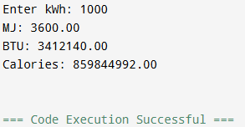

TASK 6 :
CODE :
#include <stdio.h>

float totalRevenue(float arr[], int n) {
float sum = 0;
for (int i = 0; i < n; i++) sum += arr[i];
return sum;
}

int bestTable(float arr[], int n) {
int idx = 0;
for (int i = 1; i < n; i++)
if (arr[i] > arr[idx]) idx = i;
return idx;
}

int isProfitable(float total) {
return total > 10000;
}

int main() {
float bills[5];

printf("Enter 5 table bills:\n");
for (int i = 0; i < 5; i++)
scanf("%f", &bills[i]);

float total = totalRevenue(bills, 5);

printf("Total: %.2f\n", total);
printf("Best Table: %d\n", bestTable(bills, 5) + 1);

if (isProfitable(total))
printf("Profitable\n");
else
printf("Not Profitable\n");

return 0;
}
EXECUTION :
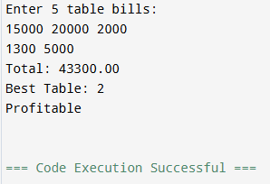

TASK 7 :
CODE :
#include <stdio.h>
int main() {
int arr[6] = {45, 50, 60, 30, 55, 40};
int *p = arr;
int highest = *p;
for (int i = 1; i < 6; i++) {
if (*(p + i) > highest)
highest = *(p + i);
}
printf("Original:\n");
for (int i = 0; i < 6; i++)
printf("%d ", *(p + i));
for (int i = 0; i < 6; i++) {
*(p + i) = (int)(((float)*(p + i) / highest) * 100);
}
printf("\nScaled:\n");
for (int i = 0; i < 6; i++)
printf("%d ", *(p + i));
return 0;
}
EXECUTION :
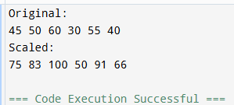
TASK 8 :
CODE :
#include <stdio.h>

int main() {
void *sensor;
int vibrations = 847;
float temperature = 73.6;
char status = 'W';
sensor = &vibrations;
printf("Vibration: %d\n", *(int *)sensor);
printf("Address: %p\n\n", sensor);
sensor = &temperature;
printf("Temperature: %.1f\n", *(float *)sensor);
printf("Address: %p\n\n", sensor);
sensor = &status;
printf("Status: %c\n", *(char *)sensor);
printf("Address: %p\n\n", sensor);
if (*(char *)sensor == 'N')
printf("Normal\n");
else if (*(char *)sensor == 'W')
printf("Warning\n");
else
printf("Critical\n");

return 0;
}

EXECUTION :
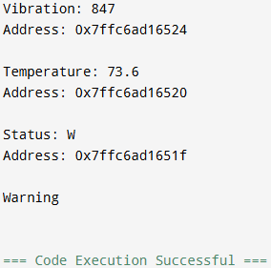

TASK 9 :
CODE :
#include <stdio.h>
int main() {
int attendance[4][5] = {
{1, 1, 0, 1, 1},
{1, 0, 0, 1, 0},
{1, 1, 1, 1, 1},
{0, 0, 1, 0, 1}
};
int (*p)[5] = attendance;
for (int i = 0; i < 4; i++) {
int total = 0;
printf("Student %d: ", i + 1);
for (int j = 0; j < 5; j++) {
printf("%d ", (*(p + i))[j]);
total += (*(p + i))[j];
}
printf(" | Total: %d", total);
if (total < 3)
printf(" (At risk)");
printf("\n");
}
return 0;
}

EXECUTION :
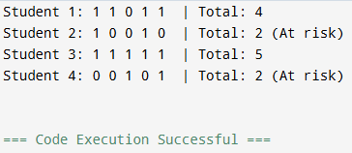

TASK 10 :
CODE :
#include <stdio.h>
int basicAttack(int dmg, int hp) {
return hp - dmg;
}
int powerStrike(int dmg, int hp) {
return hp - (int)(dmg * 2.5);
}
int heal(int dmg, int hp) {
return hp + 20;
}
int poisonAttack(int dmg, int hp) {
printf("Poison applied!\n");
return hp - (dmg / 2);
}
int main() {
int hp = 100, dmg = 25, choice;
int (*action)(int, int);
for (int i = 0; i < 3; i++) {
printf("\n1.Basic 2.Power 3.Heal 4.Poison\n");
scanf("%d", &choice);
if (choice == 1) action = basicAttack;
else if (choice == 2) action = powerStrike;
else if (choice == 3) action = heal;
else action = poisonAttack;
hp = action(dmg, hp);
printf("HP now: %d\n", hp);
}
return 0;
}
EXECUTION :
